Abstract template for HMM 2023
Name Surname¹, Name Surname^{1,2},
¹Affiliation 1
²Affiliation 2

This is the abstract template which must be used to submit a contribution to the 13th International Symposium on Hysteresis Modeling and Micromagnetics (HMM 2023), which will take place at TU Wien (Vienna, Austria) on June 5-7, 2023. A picture of the main building of TU Wien, the venue of HMM 2023, can be found in Figure 1.

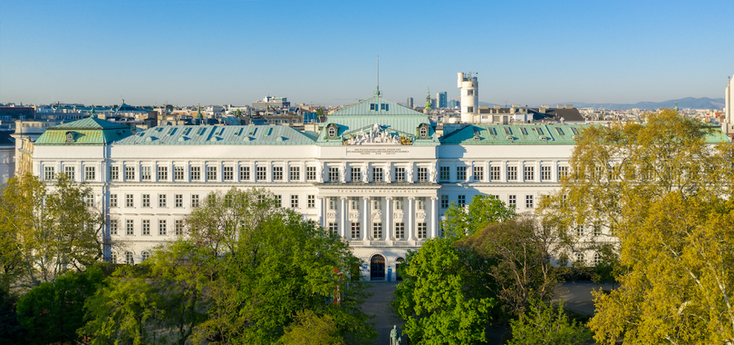
Figure 1: HMM 2023 venue (© Matthias Heisler).

Please prepare your abstract following the guidelines available here (please do not modify the template, i.e., do not alter font, spacing, margins, etc.). Each abstract should not exceed one page. If the contribution involves more than one author, please make sure that the presenting author is underlined. A figure with caption and a list of references [1,2,3] may be included.
Save the abstract in pdf format as Surname_Abstract_HMM2023_Format.pdf, where Surname should be replaced by the surname of the presenter, whereas Format is either Oral or Poster, depending on the preferred presentation format. If a presenter submits more than one contribution, please add a numeral after the surname, e.g., Surname2_Abstract_HMM2023_Oral.pdf. Each file should not be larger than 10 MB.
Submit your abstract using the HMM submission system (you will need to create an account for that).
The submission deadline is February 28, 2023.

References
[1] A. Surname1, B. Surname2, and C. Surname3: Title. Journal, volume, pages (year).
[2] A. Surname1 and B. Surname2: Title. Journal, volume, pages (year).
[3] A. Surname, et al.: Title. Journal, volume, pages (year).

