Title of Talk
(2nd line of title)
F. Author¹, S. Author², T. Author¹,…, L. Author²
Email_presenting_author@uni.ac.tv
¹Institute of Materials Chemistry, TU Wien, Austria
²Institute of Materials Chemistry, TU Wien, Austria
This template uses a Times New Roman font [1]. You can use alternates for the abstract as well, but make sure that the text style is consistent². Also make sure that the abstract fits to a single page including an optional figure + caption and references.
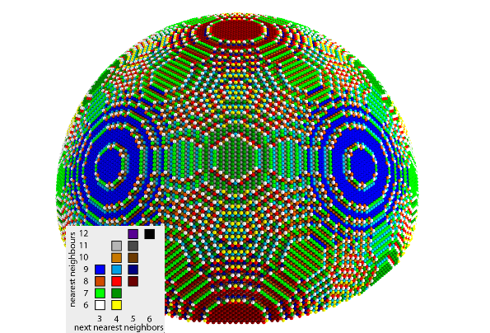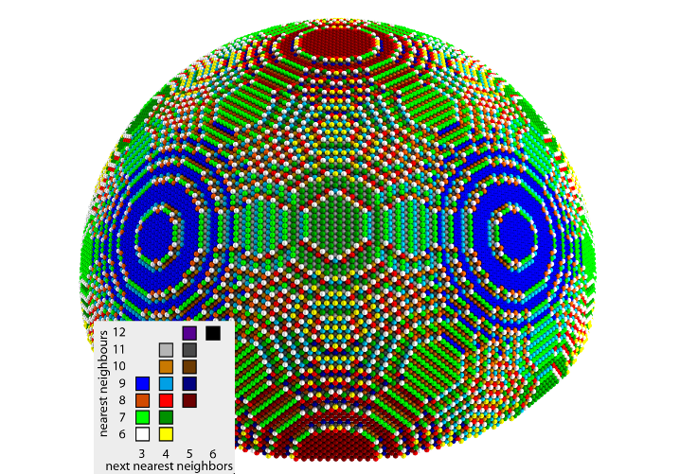
(a)
(b)
This is a figure caption is centered with respect to the figure.
(a) left part of figure (b) right part of figure

[1] Place numbered references at the bottom and use a consistent indication at the appropriate place in the abstract.
(2) Format your references in a scientific standard format to your preference.

