**Bachelor Thesis / or Master Thesis / or Dissertation**

**[16 pt. font size, 1.5 line spacing]**

**Title of Thesis [24 pt font size, 1.5 line spacing]**

carried out for the purpose of obtaining the degree of Bachelor of Science (BSc) /

Diplom-Ingenieur_in (Dipl.-Ing.in oder DI) / Doctor technicae (Dr. techn.),

submitted at TU Wien

**Faculty of Mechanical and Industrial Engineering** [12 pt font size, 1.5 line spacing]

by

**First name SURNAME [16 pt font size, 1.5 line spacing]**

Mat.No.: 0000000 [12 pt font size, 1.5 line spacing]

under the supervision of [12 pt font size, 1.5 line spacing]

**Univ.Prof.in Dipl.-Ing.in Dr.in First name, Last name**  
Institute of …, E… [12 pt font size, 1.5 line spacing]

Reviewed by (only for Dissertations)

**Name of Reviewer 1**

Institute, Address

and

**Name of Reviewer 2**

Institute, Address

Place, Date ________________________

*Signature*

This work has been supported by (indicate funding agency) within the framework of the project (indicate project name or number here). [font size 12, line spacing 1.5]

I confirm, that the printing of this thesis requires the approval of the examination board.

***Affidavit***

I declare in lieu of oath, that I wrote this thesis and carried out the associated research myself, using only the literature cited in this volume. If text passages from sources are used literally, they are marked as such. [font size 12, line spacing 1.5]

I confirm that this work is original and has not been submitted for examination elsewhere, nor is it currently under consideration for a thesis elsewhere.

I acknowledge that the submitted work will be checked electronically-technically using suitable and state-of-the-art means (plagiarism detection software). On the one hand, this ensures that the submitted work was prepared according to the high-quality standards within the applicable rules to ensure good scientific practice "Code of Conduct" at the TU Wien. On the other hand, a comparison with other student theses avoids violations of my personal copyright. [font size 12, line spacing 1.5]

*Place and Date Signature*

Acknowledgements [24 pt. font size, 1.5 line spacing]

I would like to express my sincerest gratitude to ……….the whole Super Group is acknowledged for their friendship and support in many difficult ways. **[12 pt. font size, 1.5 line spacing]**

I would like to especially thank my thesis adviser …….. for her guidance, help and constant support during the whole research work ……...

I thank ……. for his assistance by the iron depositions und …….. for his excellent TE(A)M-work.

Appreciation is also extended to the members of the Institute of ……., who gave me the ……..all the time.

I also want to say thank you ………, ……. always remind me what is really important in life and thank all my friends and study colleagues for the great time.

(maybe a nice final remark like: *"Not everything that counts can be counted, and not everything that can be counted counts."* Albert Einstein)

Table of Contents [24 pt. font size, 1.5 line spacing]

Page

Table of Contents **[12 pt. font size, 1.5 line spacing]** I

English Abstract II

Deutsches Abstract III

**1 Name of Chapter 1 (like Introduction and Motivation) 1**

**2 Name of Chapter 2 2**

2.1 Name of Chapter 2.1 3

2.2 Name of Chapter 2.2 4

2.3 Name of Chapter 2.3 6

2.3.1 Name of Chapter 2.3.1 6

2.3.2 Name of Chapter 2.3.2 8

2.4 Name of Chapter 2.4 9

**3 Name of Chapter 3 11**

**n Name of Chapter n m**

(maybe) List of Figures IV

(maybe) List of Tables V

(maybe) List of Abbreviations and Symbols VI

Appendix VII

**English Abstract [font size 24, 1.5 line spacing]**

Text, text, text [font size 12, 1.5 line spacing]. There is no reference in the abstract and abbreviations need to be defined!

**Abstracts (*ab*=out, *trahere*=pull; “to pull out”)**

* Overview of the main story
* Gives highlights from each section of the paper
* Limited length (100-300 words, typically)
* Stands on its own
* Used, with title, for electronic search engines
* Most often, the only part people read

**An Abstract Gives:**

* Background
* Question asked (“We asked whether,” “We hypothesized that,”…etc.)
* Experiment(s) done:
  + Material studied (steel, nitrides…) or computation…
  + Experimental approach or study design …
* Results found
  + Key results found
  + Minimal raw data (the most important ones, but try to summaries)
* The answer to the question asked
* Implication, speculation, or recommendation

**Important:**

* Try for **one sentence** each on **motive**, **method**, **key results, conclusions**.
* State the problem
* Say why it’s an interesting problem
* Say what your solution achieves
* Say what follows from your solution
* Don’t exceed 3 sentences on any of these!

**Deutsche Kurzfassung [font size 24, 1.5 line spacing]**

Deutsche Kurzfassung! (Bitte nicht einfach nur aus dem Englischen übersetzen)!

**List of Figures [font size 24, 1.5 line spacing]**

Page

Fig. 1: Title of Figure 1 [font size 12, 1.5 line spacing] 4

Fig. 2: Title of Figure 2 7

. .

. .

. .

Fig. n: Title of Figure n m

**List of Tables [font size 24, 1.5 line spacing]**

Page

Table 1: Title of Table 1 [font size 12, 1.5 line spacing] 4

Table 2: Title of Table 2 7

. .

. .

. .

Table n: Title of Table n m

**List of Abbreviations and Symbols [font size 24, 1.5 line spacing]**

[font size 12, 1.5 line spacing]

SEM Scanning electron microscope

PVD Physical Vapor Deposition

R&D Research and Development

. .

. .

λ Wave length

Ω Atomic volume

**1 Introduction and Motivation [font size 24, 1.5 line spacing]**

Text, Text, Text, …[12 pt. font size with 1.5 line spacing, preferred Times New Roman or Calibri] Text, Text, Text, …

Text: Indicate references by number(s) in square brackets in line with the text. The actual authors can be referred to, but the reference number(s) must always be given.  
Example: "..... as demonstrated [3,6]. Barnaby and Jones [8] (or Barnaby et al. []; if more than one or two authors) obtained a different result ...."

Give the numbers in correct orders (1 before 2 and so on). Do not refer to [8] if in the previous text you never used [7] for example…..

**COMMAS (,):**

Common sense can be a reliable guide; if you think your readers need to pause, offer them a well-placed comma. (See also “e.g. and i.e.,”)

* Use the serial comma before conjunctions (e.g., metallic, conductive, and brittle materials).
* Separate the parts of a compound sentence (unless it is very short) that are linked by a coordinating conjunction—and, but, or, or nor—when each part has its own subject and verb (e.g., The subsystem will be delivered in two weeks, and we will modify it for deposition work.).
* **Do not use commas as decimal points (mostly European convention); use periods.**
* Set off nonrestrictive or nonessential (parenthetical) words, phrases, and clauses from the rest of the sentence; in other words, the commas signal that the information between them is something extra—and not essential to the meaning of the sentence (e.g., **The subsystem, which takes a day or two to install, will be delivered in two weeks.**).
* Do not use commas to separate compound subjects (more than one subject) from a single verb or compound verbs from a single subject:  
  **Theorists and nonspecialists alike agree on the importance of this discovery.  
  The researchers rolled out the metal sheet and formed it into coils.**
* Commas are not necessary when words, phrases, or clauses are restrictive or essential to the meaning of a sentence:  
  **Only the sensors that were attached to the outer edge failed.**  
  **The system will work efficiently if it includes storage.**

**Seven Comma Rules:**

1. **Put a comma before and, but, for, or, nor, yet, so when they connect two independent clauses.**
   * *We lost our oars, and that was the end of our boating.*
   * *We leave Friday, or we may wait until Monday.*
   * *I wanted to go but could not get my car started.*

The last example does not have two independent clauses; therefore, no comma is needed.

1. **Put a comma between items in a series.** 
   * *Hurrah for the red, white, and blue.*
   * *She put down the phone, picked up her purse, and left.*

But: no comma is needed for: The *eager little* boy

The way to tell whether a comma is needed between two words in a series is to see whether the word "and" could be used naturally between them. Simply use a comma where the word "and" could be used.

If an address or date is used in a sentence, treat it as a series, putting a comma after every item, including the last: He was born on May 17, 1959, in Salisbury, North Carolina, and grew up there.

She lived at 2340 Tenth Avenue, Doylestown, Pennsylvania, for two years.

1. **Put a comma after an introductory expression that does not flow smoothly into a sentence.**
   * *Yes, I'll go.*
   * *Well, that was the end of that.*
   * *Rushing down the hill, she slipped and fell.*
   * *When everyone had left, the auditorium was locked for the night.*

A dependent clause at the beginning of a sentence usually needs a comma after it. In the last example, you can see that a comma is necessary. Otherwise, the reader would read "When everyone had left the auditorium..." before realizing that that was not what the writer meant. A comma makes the reading easier.

1. **Put commas around the name of a person spoken to.** 
   * *I think, Bianca, you are absolutely right.*
   * *Craig, how about a game of tennis?*
2. **Use commas to set off expressions such as he said or she asked from direct quotations.** 
   * *He said, "Our team will win the championship."*
   * *"Our team," the coach asserted, "will win the championship."*
   * *"Our team will win the championship," John stated.*
3. **Put commas around an expression that interrupts the flow of the sentence.**

*(for example: however, moreover, finally, therefore, of course, by the way,)*

* + *He thought, however, that I should wait.*
  + *It should, I think, take only an hour.*

But “I think, I am sure, and similar expressions” are not interrupters if they occur at the beginning of the sentence, so they don't require commas.

* + *I think it should only take an hour.*

“However, therefore, on the other hand, etc.,” **still require commas** if they begin the sentence, and if they come between two independent clauses require a semicolon in front of them and a comma after.

* + - *He was busy; however, he took time to help.*

1. **Put commas around nonessential material.**

The material may be interesting, but the main idea of the sentence would be clear without it.

* + - *Gladys Nolan, who is heading the United Fund drive, broke her ankle.*

The clause “who is heading the United Fund drive” is not essential to the main idea of the sentence. Without it we still know exactly who the sentence is about and exactly what she did: Gladys Nolan broke her ankle. But in the following sentence:

* + - *The woman who is heading the United Fund drive broke her ankle.*

The clause "who is heading the United Fund drive" is essential to the main idea of the sentence. Therefore, commas are not used around it.

**2 Title of Chapter 2 [font size 24, 1.5 line spacing]**

Text, Text, Text, [1].

Text, Text, Text, … [12 pt. font size, 1.5 line spacing]

**2.1 Title of Subchapter [font size 14, 1.5 line spacing]**

Text, Text, Text, ....

Text, Text, Text, ....

**2.1.1** **Title of Sub-Subchapter [font size 14, 1.5 line spacing]**

Text, Text, Text, ...., see Fig. 2.1.

Figure 2.1 shows Text, Text, Text, ....

* **Text:** not all analyses or results warrant a Table or Figure. Some simple results are best stated in a single sentence, with data summarized parenthetically:  
  *“The friction coefficient was lower for testing against cemented carbide (0.36 ± 0.08) than for alumina balls (0.65 ± 0.12).”*
* **Tables and Figures should summarize results**, not present large amounts of raw data.
* **Tables:** Tables present lists of numbers or text in columns, each column having a title or label. **Do not use a table when you wish to show a trend** or a pattern of relationship between sets of values - these are better presented in a Figure.
* **Figures:** Figures are **visual presentations of results**, including graphs, diagrams, photos, drawings, schematics, etc. Graphs are the most common type of figure showing trends.
* **Every Figure and Table MUST be referred to from the text**. **In the CORRECT Order!! (1 before 2; 1a before 1b......)**
  + Aim for a concise, economical style!
    - **Poor**: It is clearly shown in Fig. 3 that the shear loading had caused the cell-walls to suffer ductile fracture or possibly brittle failure.
    - **Better**: Shear loading fractures the cell-walls, see Fig. 3.

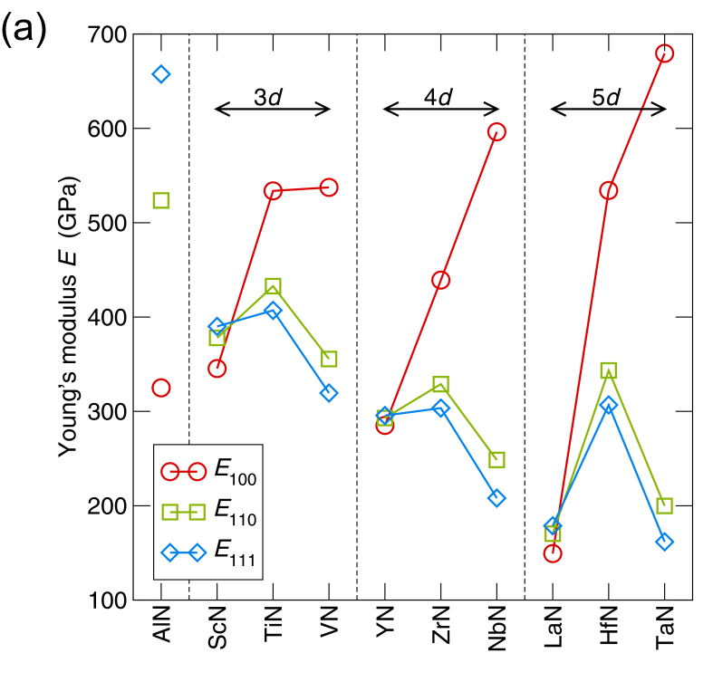

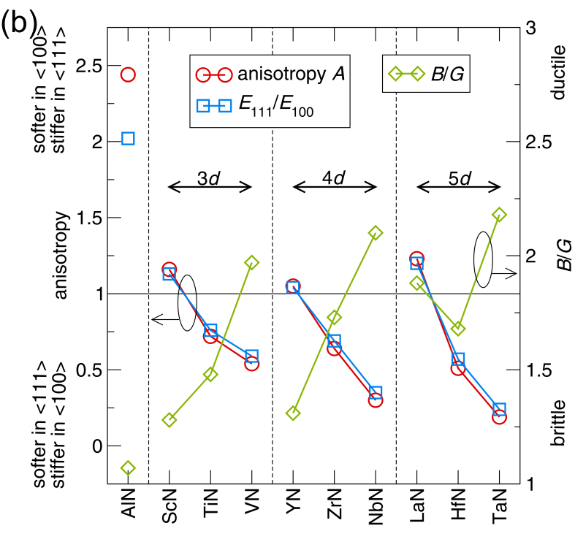

**Fig. 2.1** **(a)** Young’s modulus in the 〈100〉, 〈110〉, and 〈111〉 directions and **(b)** Zener’s anisotropy ratio E〈111〉/E〈100〉 and B/G values (bulk modulus/shear modulus) for the ten nitrides studied [Ref]. **[font size 12, 1 line spacing]**

* Abscissa and ordinate must be clearly labeled, units of measurement must be given!
* **Avoid shades and grid-lines!**
* **Use unambiguous symbols, which can be easily distinguished in b/w!** Clearly identify the different symbols in the legend! Please use colors BUT also Keep in mind that the individual lines, data points need to be distinguish-able also for printing in black and white.
* “Guidelines for the eye” may be helpful to visualize a trend.
* **Error bars should be included!**
* Use appropriately sized numbers, letters, and symbols, which are readable after reduction of the figure to the published size!
* **Numbers, letters, and symbols used in multi-paneled figures must be consistent!**
* Use labels **a, b, c,** etc. in multi-paneled figures!
* **Don’t be sloppy.** Make sure that elements of your figures are properly aligned, letter sizing is consistent, etc. A sloppy figure means a sloppy scientist!
* **Make a figure as simple as possible**, no need to show your skills in preparing e.g., 3D graphs, if no additional information is given.
* Avoid small symbols and **The size of the lettering should be no less than 1.5 mm.**
* **The figures are a major part of any thesis or paper; please design them as easy for the readers as possible!**

**Table 2.1**: Typical table title is short without ending punctuation **[font size 12, 1 line spacing]**

|  |  |  |  |  |  |  |  |
| --- | --- | --- | --- | --- | --- | --- | --- |
|  | Spanner heada | | |  | Spanner headb | | |
| Stub head | Col head | Col head | Col head |  | Col head | Col head | Col head |
| [stub] |  |  |  |  |  |  |  |
| Row head | [column] | [column] | [column] |  | [column] | [column] | [column] |
| Row subhead | xxx | xxx | xxx |  | xxx | xxx | xxx |
| Row subhead | xxx | xxx | xxx |  | xxx | xxx | xxx |
| Row subhead | xxx | xxx | xxx |  | xxx | xxx | xxx |
| Row head | [column] | [column] | [column] |  | [column] | [column] | [column] |
| Row subhead | xxx | xxx | xxx |  | xxx | xxx | xxx |
| Row subhead | xxx | xxx | xxx |  | xxx | xxx | xxx |
| Row subhead | xxx | xxx | xxx |  | xxx | xxx | xxx |
| Total | xxx | xxx | xxx |  | xxx | xxx | xxx |
| a[footnote] explanation or Source: xxxx. [period]  b[footnote] explanation or Source: xxxx. [period] | | | | | | | |

**table in 12 pt. font size and 1.5 line spacing!**

Major parts of a table (Source: Scientific Style and Format. The CBE Manual for Authors, Editors and Publishers, 1994. The Council of Biology Editors, 6th Edition, 825 pp.)

* Try to keep Tables as simple as possible.
* **Do not do “data-dumping”** - this is where the **author** actually just says ”hey, I am too busy/lazy to summarize the information for you. Just go and look in the table and figure this out for yourself!”
* Avoid backgrounds, use only concise lines to separate the headings from the content.
* Always include units (as appropriate) for every column (or row) of your table.
* Tables may have notes at the bottom providing information necessary to understand the data presented.
* Present simple formulae in the line of normal text where possible and use the solidus (/) instead of a horizontal line for small fractional terms, e.g., 1/2
* In principle, **variables are to be presented in italics**.
* **Explain every variable the first time it is used!**
* **Number consecutively any equations** that have to be displayed separately from the text. For example:

 (2.1)

and referring the equation with Eq. (2.1), Eq. (2.2), …, in the text.

* Center the equations, and right-justify the equation numbers [see Eq. (2.1)].
* Powers of e are often more conveniently denoted by “exp”.
* Variables that are *italicized* in an equation should be italicized in text as well. Do not use *italic type* for Greek variables.
* When referring to equations in text, capitalize the word Equation and include the number within parentheses [e.g., as given in Eqs. (1), (2), and (3)]. Keep the parentheses. Not: … given in Eqs. (1, 2, and 3).

**List of References [font size 24, 1.5 line spacing]**

Text: Indicate references by number(s) in square brackets in line with the text. The actual authors can be referred to, but the reference number(s) must always be given.  
Example: "..... as demonstrated [3,6]. Barnaby and Jones [8] obtained a different result ...."

Reference list: Number the references (numbers in square brackets) in the list in the order in which they appear in the text.

**Reference to a journal publication**: **[font size 12, 1.5 line spacing]**

1 J. van der Geer, J.A.J. Hanraads, R.A. Lupton, *Title of paper*, J. Sci. Commun. 163 (2000) 51–59.

2 J. Lin, W.D. Sproul, J.J. Moore, S. Lee, S. Myers, *Title of paper*, Surf. Coat. Technol., accepted, doi:10.1016/j.surfcoat.2010.11.039

**Reference to a book**: **[font size 12, 1.5 line spacing]**

3 W. Strunk Jr., E.B. White, *The Elements of Style*, third ed., Macmillan, New York, 1979.

**Reference to a chapter in an edited book**: **[font size 12, 1.5 line spacing]**

4 G.R. Mettam, L.B. Adams, in: B.S. Jones, R.Z. Smith (Eds.), *Introduction to the Electronic Age*, E-Publishing, Inc. New York, 1994, pp. 281–304.

**Reference to a proceeding**: **[font size 12, 1.5 line spacing]**

5 G. Surename, G. Surename, G.H. Surename, *Titel of paper*, in Proc. 14th International Symposium on …...(Conference name), (M. Hrabovsky, M. Konrad, V. Kopecky, eds.), Institute of Plasma Physics, Prague (CZ), Vol. 3, 1999(year), pp. 281–304.